
The National Gas Company of Trinidad and Tobago Limited

Media Release

NGC and EOG Resources sign new Gas Supply Contract

May 1st, 2026
PORT OF SPAIN

The National Gas Company of Trinidad and Tobago Limited (NGC) continues to deliver on its mandate to secure reliable natural gas supply in support of the downstream sector and the wider energy industry. On Friday 1 May 2026, NGC signed a new gas supply contract with EOG Resources Trinidad Limited (EOG), marking a significant step in strengthening the country’s natural gas value chain and supporting ongoing sector stability. The signing took place at the Hyatt Regency, Port of Spain.

Notably, negotiations for this agreement were concluded eight months ahead of schedule, reflecting not only efficiency, but the strength and maturity of the longstanding relationship between NGC and EOG. Built over years of collaboration, this partnership is grounded in mutual trust, transparency, and a shared understanding of the strategic importance of natural gas to Trinidad and Tobago’s economy. NGC also commends EOG for its continued confidence in Trinidad and Tobago. In the context of the current market structure, EOG’s decision to partner with NGC underscores a deliberate commitment to the country and to the sustained development of its energy sector. This agreement reinforces a partnership that goes beyond transactional engagement, positioning both companies to continue working together to unlock value within the sector.

Acting President of NGC, Mr. Edmund Subryan commented, “NGC continues to make meaningful progress in our unwavering pursuit of supply stability for our customers and increased value for the people of Trinidad and Tobago. While there is still work to be done, we are advancing critical projects and negotiations beyond key milestones, with the support of our Board and line Ministry. The early conclusion of this agreement speaks to the strength of our relationship with EOG and what can be achieved through sustained collaboration. We commend the teams from NGC and EOG for their professionalism, resilience, and focus in bringing this contract to fruition.”

NGC Chairman, Mr. Gerald I. Ramdeen remarked, “This agreement is a testament to what can be achieved through partnership, perseverance, and a shared commitment to national development. Our relationship with EOG has been built over time and continues to be strengthened through engagements such as this. NGC has been working assiduously to conclude ongoing negotiations in a timely manner, pursuing outcomes that balance commercial priorities with the national interest. The execution of this contract—particularly ahead of schedule, signals continued investor confidence in Trinidad and Tobago’s energy sector and demonstrates NGC’s role in translating that confidence into sustainable, long-term value for the country.”

For more information:
Nicola J. Ghouralal, Manager, Corporate Communications (Ag.)
The National Gas Company of Trinidad and Tobago Limited (NGC)
Orinoco Drive, Point Lisas
nicola.ghouralal@ngc.co.tt
Follow us on social media


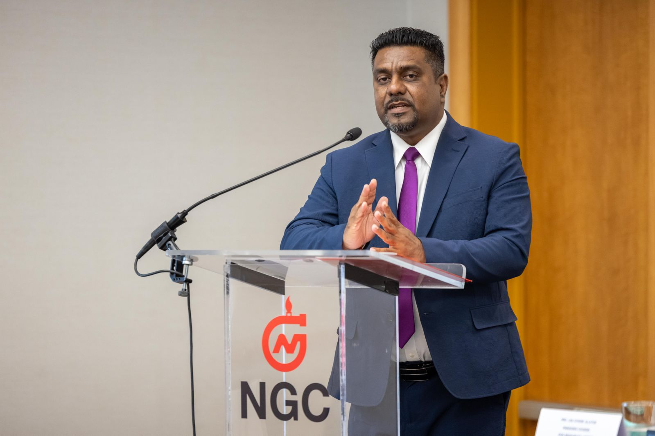

Photo 1 – Mr. Gerald I. Ramdeen, NGC Chairman, delivers remarks at the signing of the Gas Supply Contract between NGC and EOG

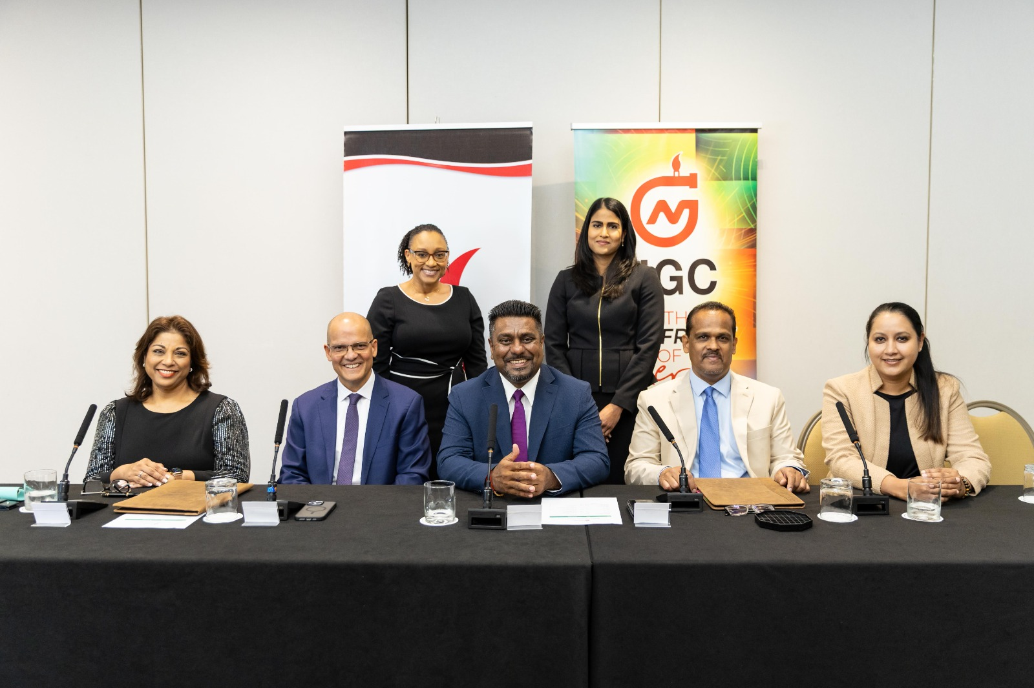
Photo 2
(L to R – front row) Mrs. Lisa Gosine-Alleyne, Managing Counsel, EOG; Mr. George Vieira, VP & General Manager, EOG; Mr. Gerald I. Ramdeen, Chairman, NGC; Mr. Edmund Subryan, President (Ag.), NGC and Ms. Karinsa Tulsie, Permanent Secretary, MEEI
(L to R – back row) Ms. Renesha Abraham, Legal Counsel II, EOG and Ms. Shivani Ramroop, VP (Ag.), Legal and Corporate Affairs, NGC

